MEDIATION AWARENESS PROGRAMME
20th April 2019
District Mediation Monitoring Committee, DLSA, District Court conducting series of Mediation Awareness Programme from time to time. Under the aegis of Mediation Action Plan 2019, District Mediation Monitoring Committee conducted Awareness programme on, “Role of Judges, Advocates and Mediators in Mediation” on 20th April , 2019, at Judges Conference Hall , 8th floor, District Court Nagpur. About 15 students of LL.B II sem. (5 YC and 3 YC) from Department of Law along with Dr. Pratima Lokhande, Coordinator of Legal Aid Clinic participated and attended the said awareness programme. The primary objective of the programme was to spread awareness about the role of Judges, Advocates and Mediators and to promote the concept of Pre-litigation Mediation, Pre-mediation and Post-mediation. This programme started with the introductory speech given by the Principal District Judge, Shri. Sawale. He explained the basics and the necessity of the Mediation. Shri Gugane, Retired Judge Senior division explained the category of cases sent for the Mediation. Mrs. Borkute, Member of DLSA proposed vote of thanks. All the students benefited from the awareness programme. It has also fostered an interest amongst students in pursuing career as a Mediator.
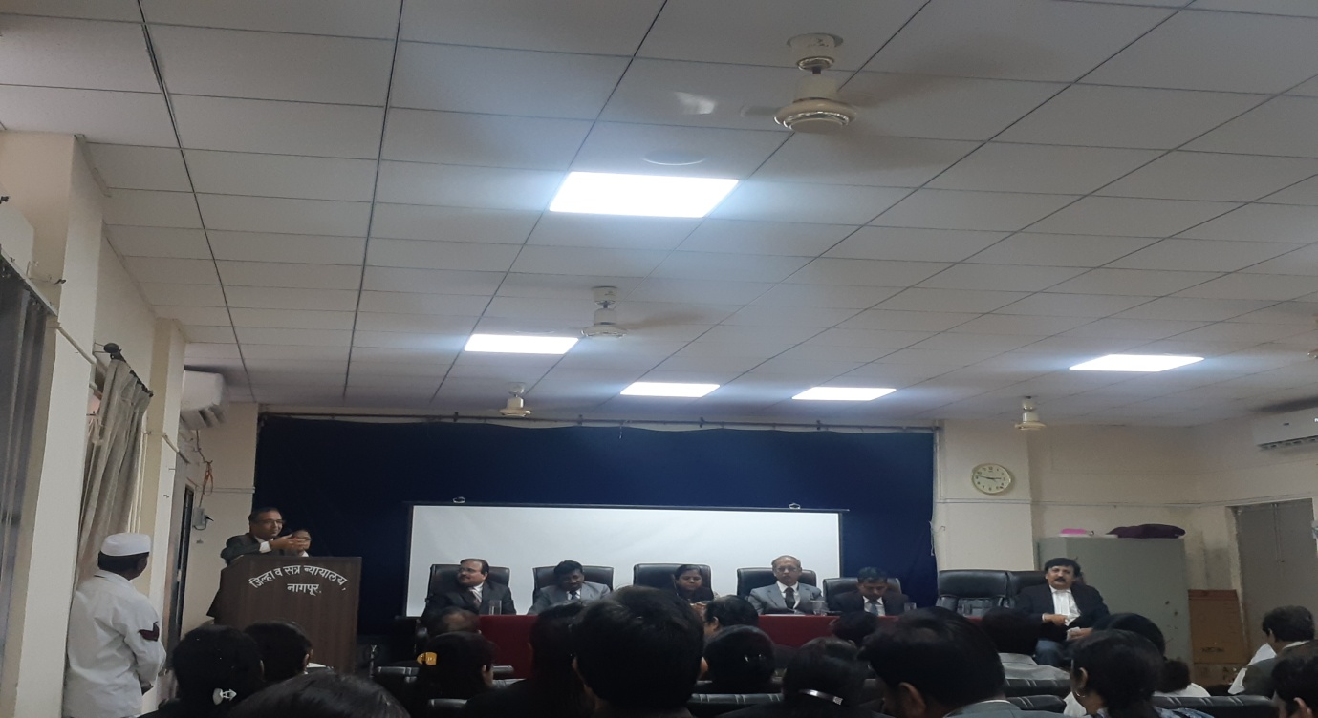
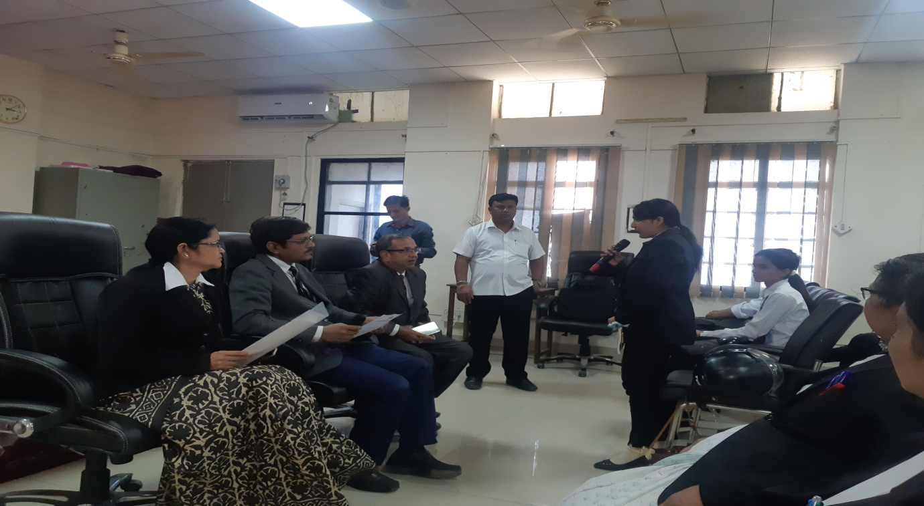
Students interacting with the Members of DLSA

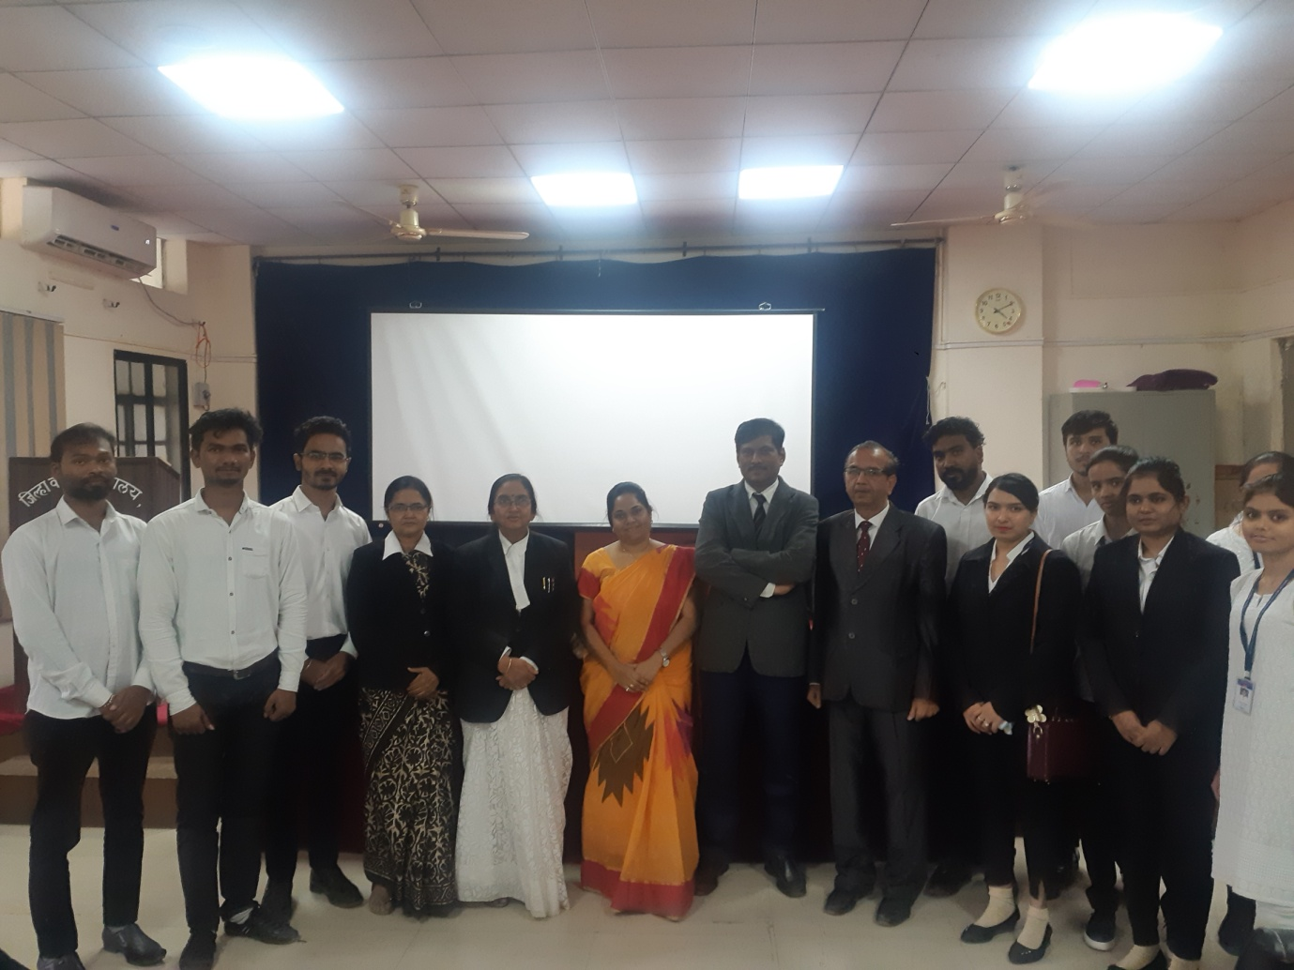

LEGAL AID CLINIC ACTIVITIES

Department of Law

- VISIT TO LOKADALAT 14th September 2019 NOTICE:
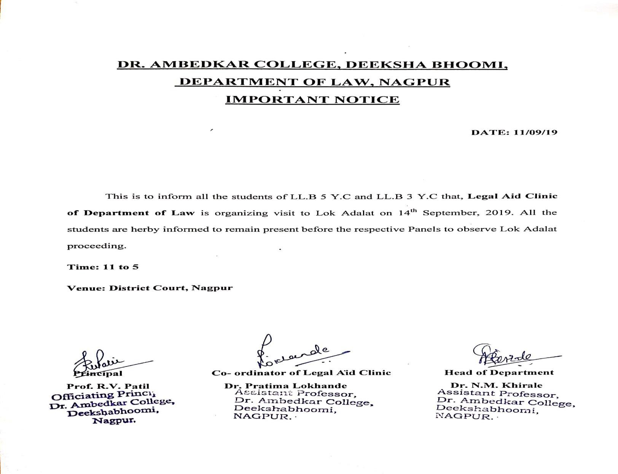

REPORT:
Students of Department of Law, Dr. Ambedkar college, DeekhaBhoomi , Nagpur on 14 th September, 2019 attended Lok Adalat at District Court, Nagpur. The students were briefly introduced with basic concepts behind the introduction and implementation of Lok Adalat Proceedings along with ADR mechanisms, i.e., Arbitration, Conciliation and Mediation Centre for the speedy disposal of cases. The students were divided into groups to attend Lok Adalat Proceedings in various matters related to Matrimonial cases, bank recovery cases, MACT, Compoundable criminal cases etc.. The students were explained various technical, procedural, legal and social aspects behind the application of legal provisions and remedies by the respective panelists. This visit was organized by Legal Aid Clinic of Department of Law.

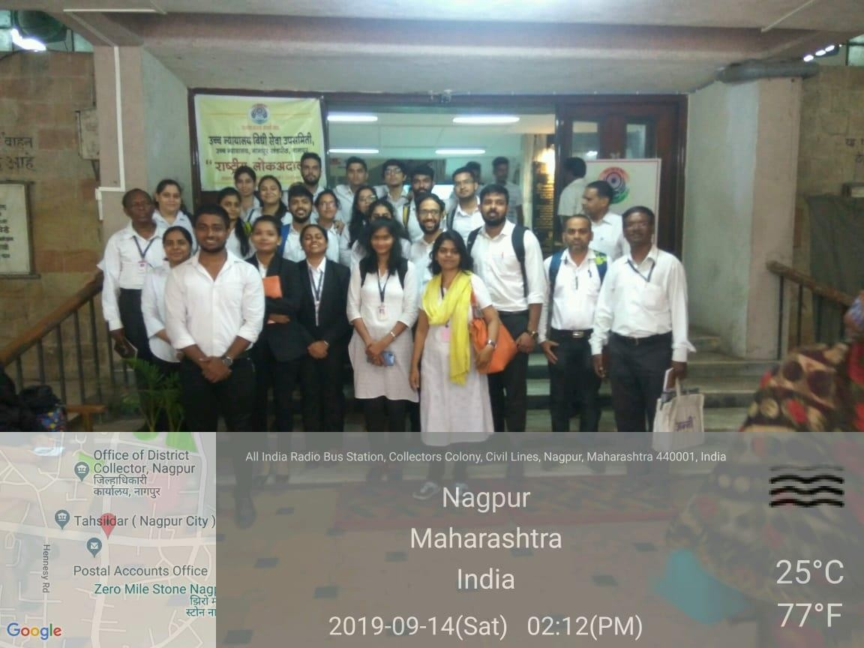

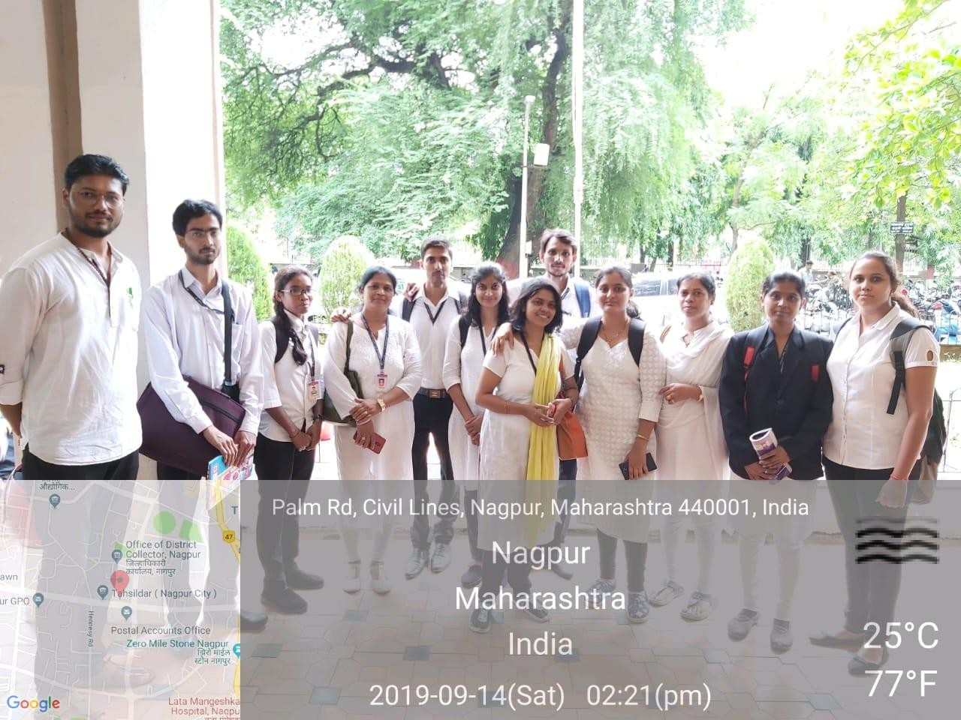

MEDIATION AWARENESS PROGRAMME
1st September 2019
District Mediation Monitoring Committee, conducted Mediation Awareness Programme on 1st September, 2019 at Judges Auditorium 8th floor, District court Nagpur. About 20 students of LL.B Final year (5 YC and 3 YC) from Department of Law along with Dr. Pratima Lokhande, Coordinator of Legal Aid Clinic participated and attended the said awareness programme. The primary objective of the programme was to spread awareness about the use of Mediation in the process of Divorce cases. This programme started with the introductory speech given by Secretary of D.L.S.A. He explained the primary objective of the Mediation as well as its importance in settling family disputes. A skit was also performed by the advocates and Mediators on the Panel of mediation centre to grow awareness, knowledge and use of mediation for resolving disputes.

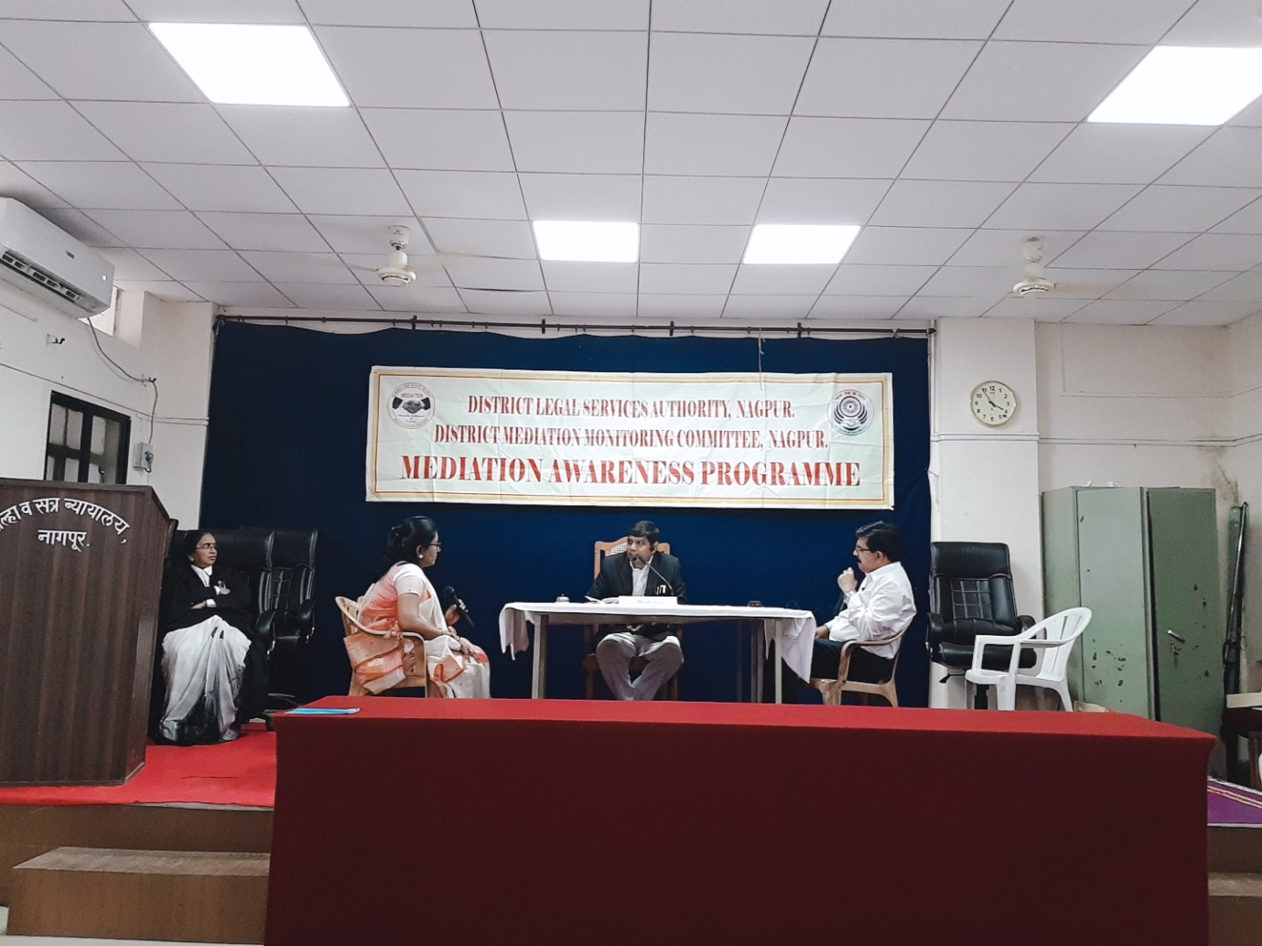
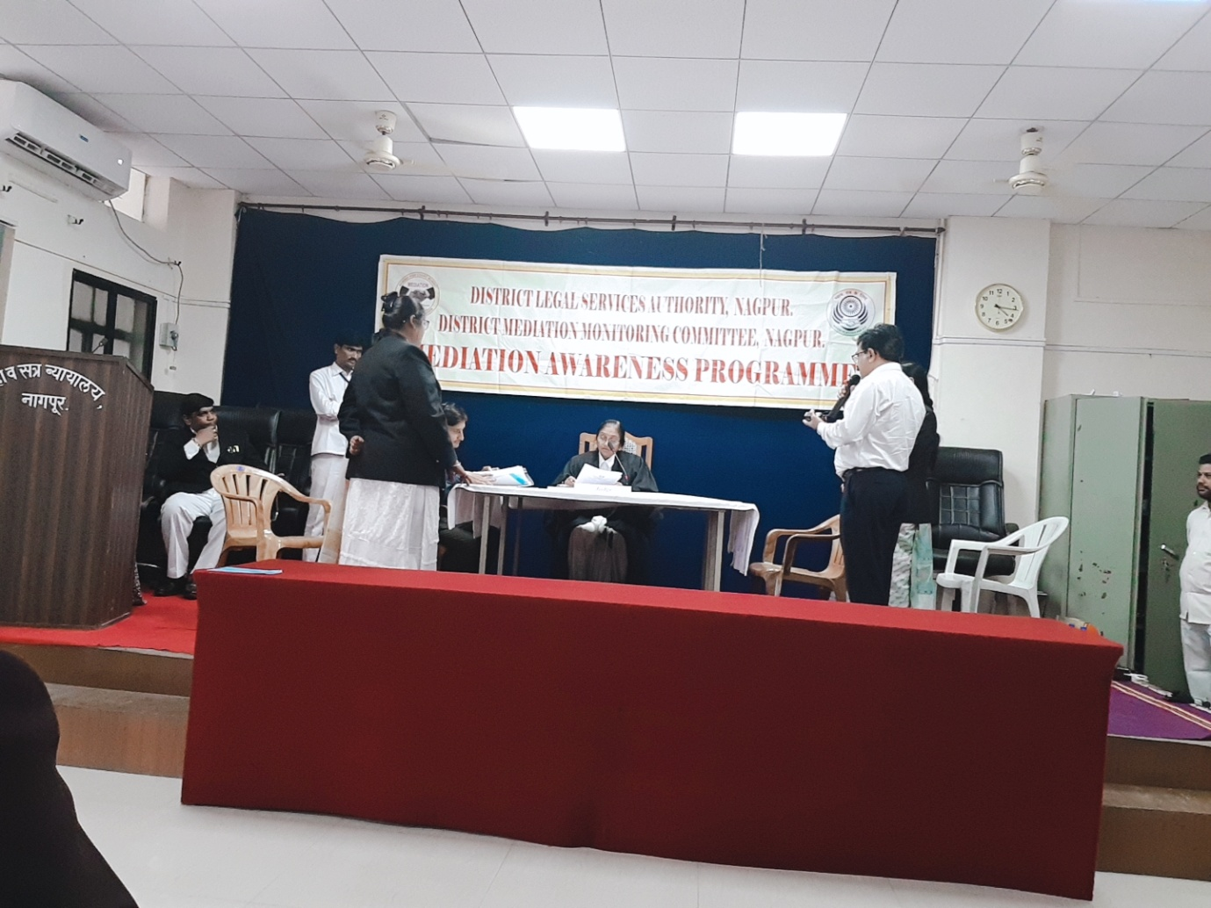
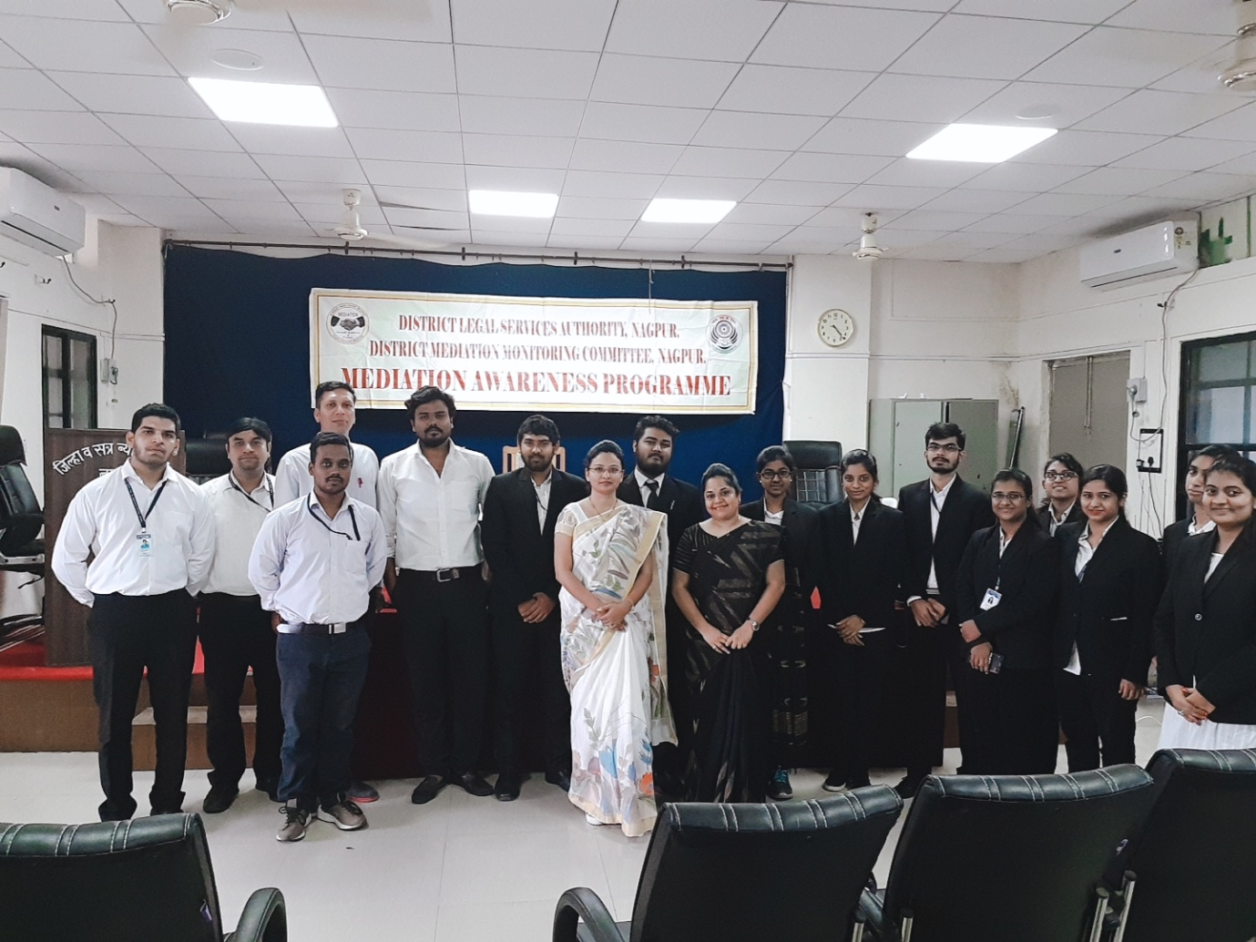

TWO DAYS FREE LEGAL AID AND LITERACY PROGRAMME

(7thand 8th October 2019)
NOTICE:
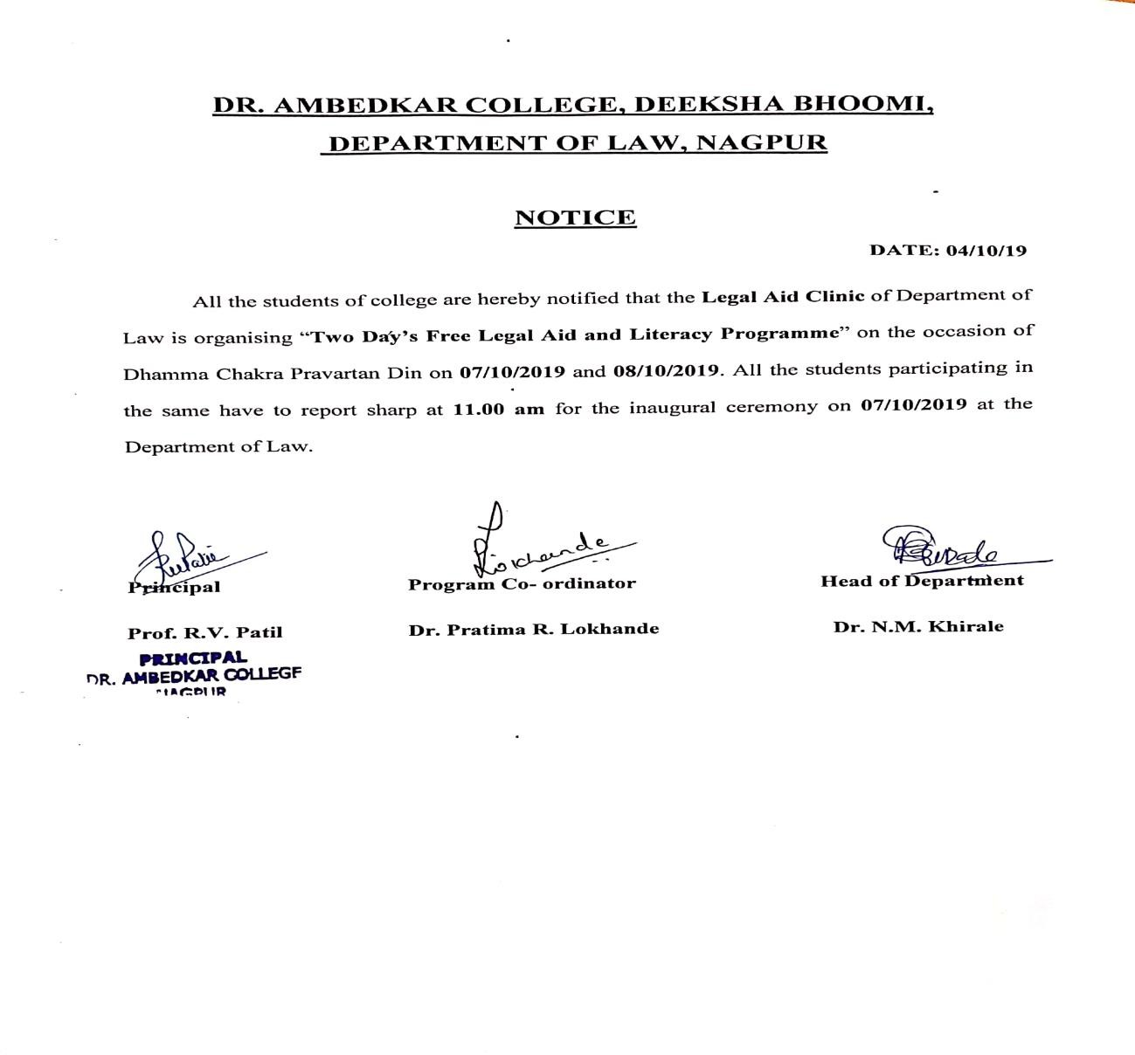

REPORT:

Two days Free Legal Aid and Literacy Programme (7th& 8th October) was inaugurated on 7th October, 2019 at the hands of Prof. (Dr.) Vijender Kumar, Vice Chancellor, Maharashtra National Law University, Nagpur and Dr. K.M. Bhandarkar, Ex- Dean (Faculty of Education), Rashtrasant Tukdoji Maharaj Nagpur University, Nagpur to mark the 63rd Dhammachakra Pravartan Din in the DeekshaBhoomi organized by the LEGAL AID CLINIC of Department of Law, Dr. Ambedkar College, Deekshabhoomi, Nagpur. Free Legal Aid and Literacy Programme is regularly organized since last 15 years by the Department of Law. This year, Department of Law has undertaken an initiative of conducting a survey on awareness amongst masses about various laws pertaining to issues like health, free and compulsory education, welfare of women and sexual offences against children. Dr. N.M. Khirale, HOD, of Law, Dr. Ambedkar College, Deekshabhoomi, Nagpur while delivering introductory address emphasized on making legal remedy more accessible to all so as to create a society as envisioned by the Constitution makers.
Addressing the students and faculty members, the Chief Guest Prof. (Dr.) Vijender Kumar highlighted the importance of legal aid as an instrument to impart justice to poor masses. He appreciated the efforts taken by the Department of Law and appealed law students and budding lawyers to pay back their Social Debt as a member of this society. He also emphasized on Reversal Parental Responsibility and remaining connected to one’s roots and culture. He also recognized the importance of organizing such Legal aid camp as it well equips young law students with all the skills and legal acumen required in the legal profession. Highlighting the life events of Dr. Babasaheb Ambedkar, Dr. K. M. Bhandarkar focused on importance of education as a way towards the emancipation of downtrodden. Shri. N.R. Sute, Member of ParamPoojya Dr. Babasaheb Ambedkar Smarak Samiti was also present on the Dias.
The Programme was attended in large number by the students of LL.B.5YC and LL.B.3YC of Department of Law, Lawyers and students of various other Law Colleges. The Programme was conducted by Mrs. Vaishali Sukhdeve. Vote of Thanks was proposed by co-ordinator of Legal Aid clinic Dr. Ms. Pratima Lokhande. Faculty members Dr. Ushoshi Guha, Dr. Mrs. Sandhya Kalamdhad, Ms. Shilpa Rathod, Ms. Shazia Bari, Mrs. Jayashree Pantavne, Mrs. Priti Awale and other staff members were prominently present.

